Classes and programming paradigms
Y13 - Cambridge International 9618 | 20.1 | Student booklet
Name: _______________________________ | Date: _____________

This booklet has everything you need for the lesson in one place. Work through it in order:
- Learn sections show the key slides. Read them carefully - they explain the ideas and show worked examples.
- Task sections are where you practise. Each task uses what the slides just before it taught you.
- Tasks build up from easier exam-style questions to real Cambridge 9618 Paper 3 and Paper 4 questions. Task 6 is homework or for the next lesson.
Learn Starter - four ways to write a program
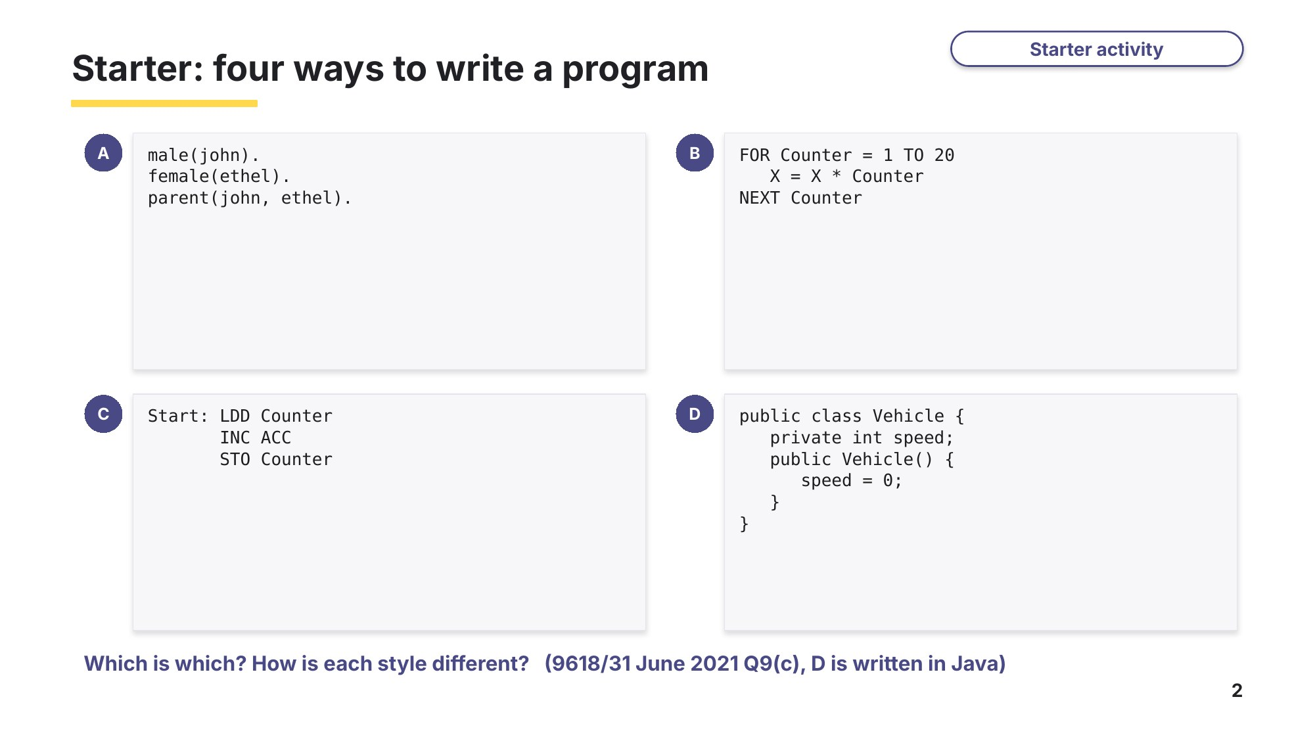
Slide 2 - Starter: which paradigm?

Task 1 Starter: four ways to write a program [4 marks]
Identify the programming paradigm for each of these program code examples: low-level, imperative (procedural), object-oriented or declarative.
9618/31 May/June 2021 Q9(c).
Program code | Programming paradigm
male(john).
female(ethel).
parent(john, ethel).
FOR Counter = 1 TO 20
X = X * Counter
NEXT Counter
Start: LDD Counter
INC ACC
STO Counter
public class Vehicle {
private int speed;
public Vehicle() { speed = 0; }
}

Learn Programming paradigms
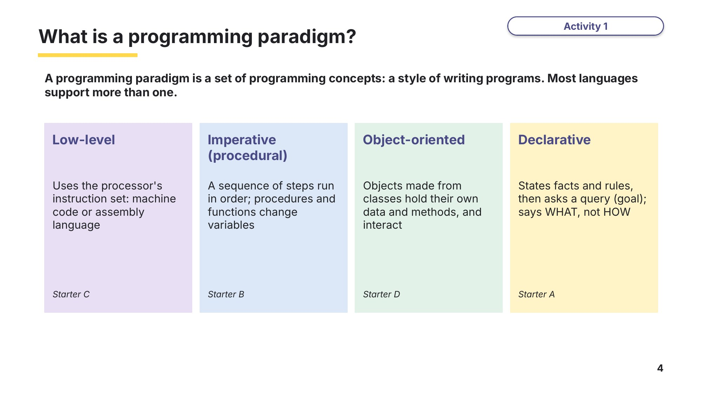
Slide 4 - Four paradigms
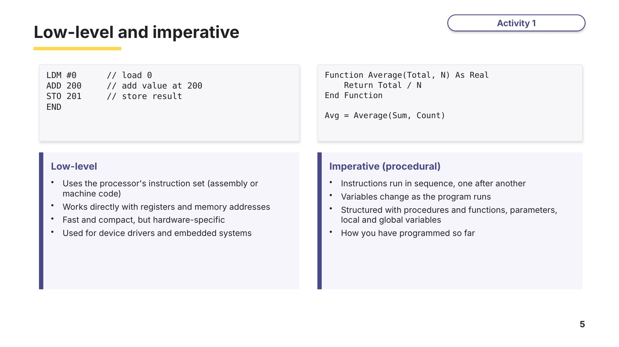
Slide 5 - Low-level and imperative
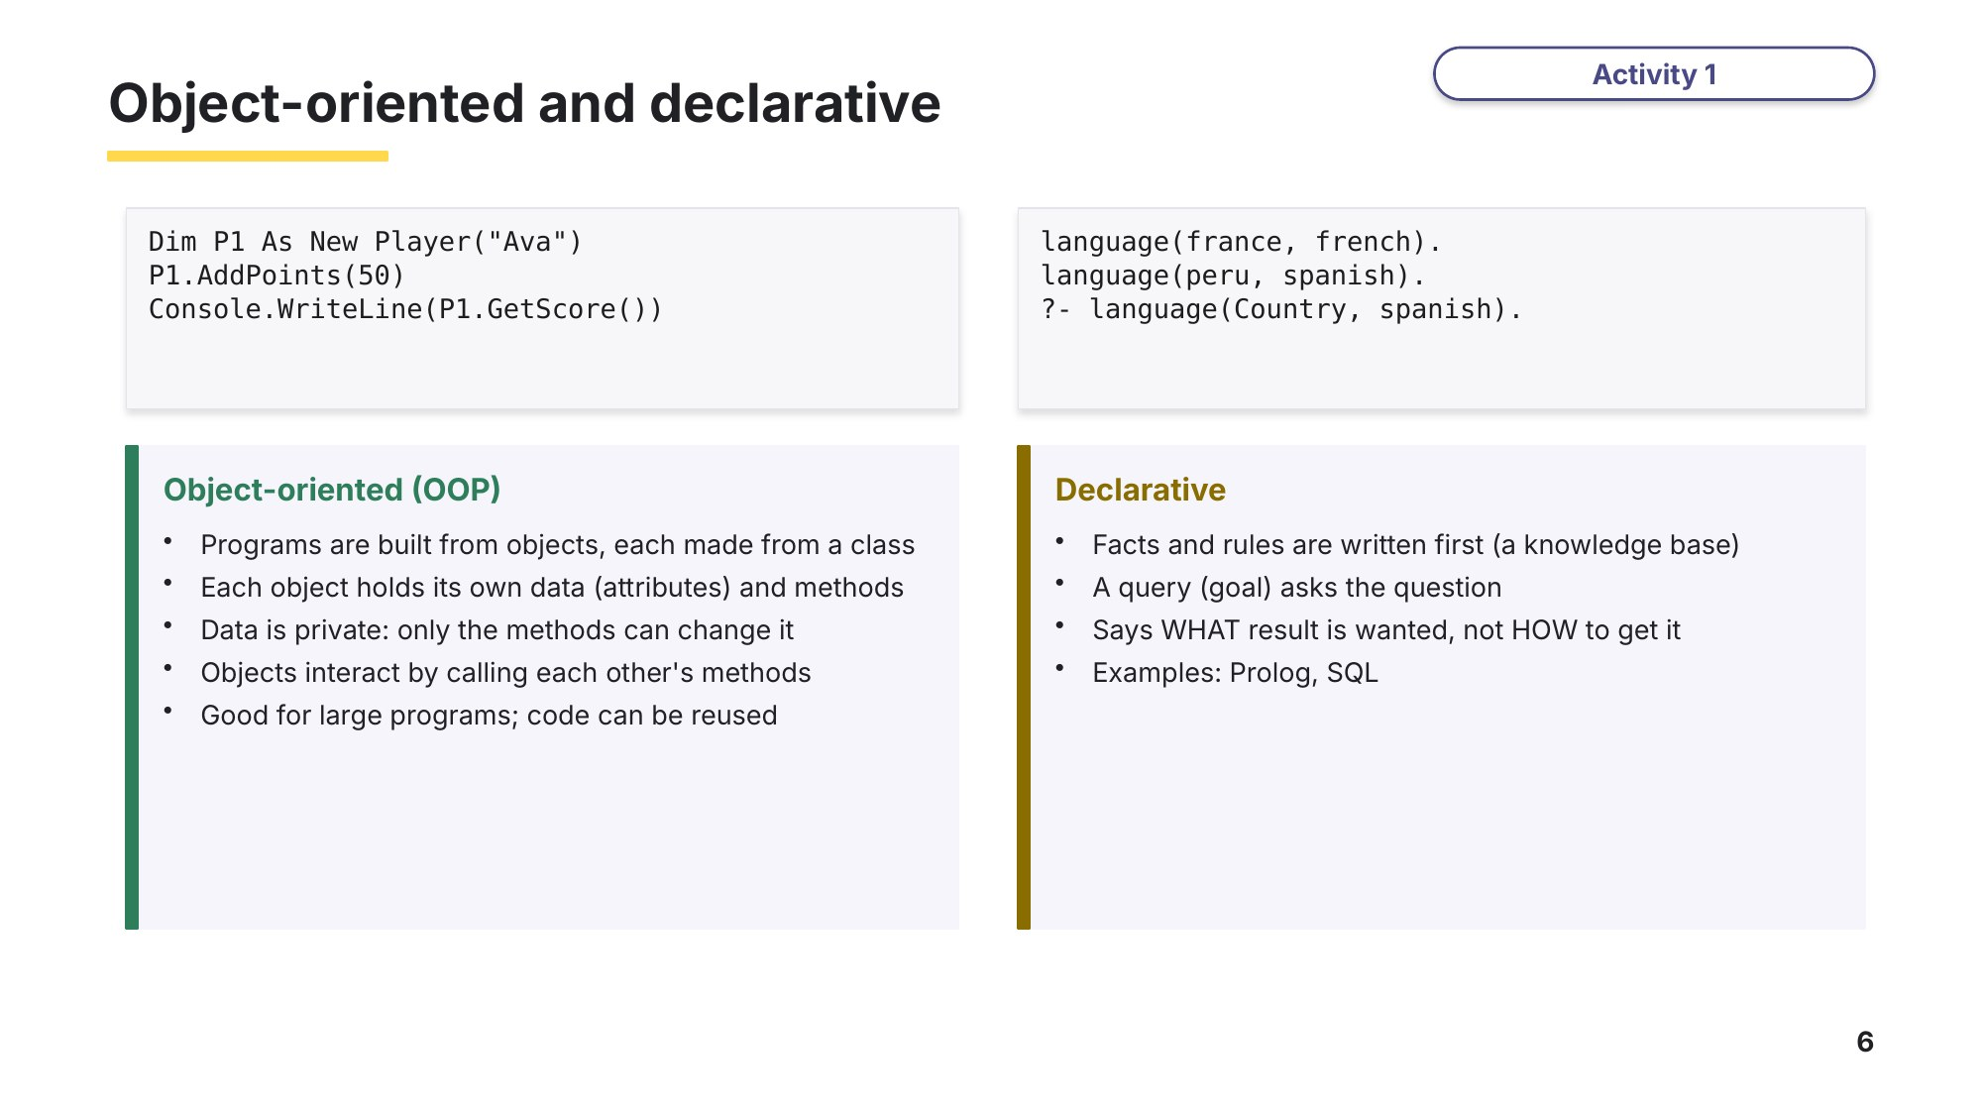
Slide 6 - Object-oriented and declarative
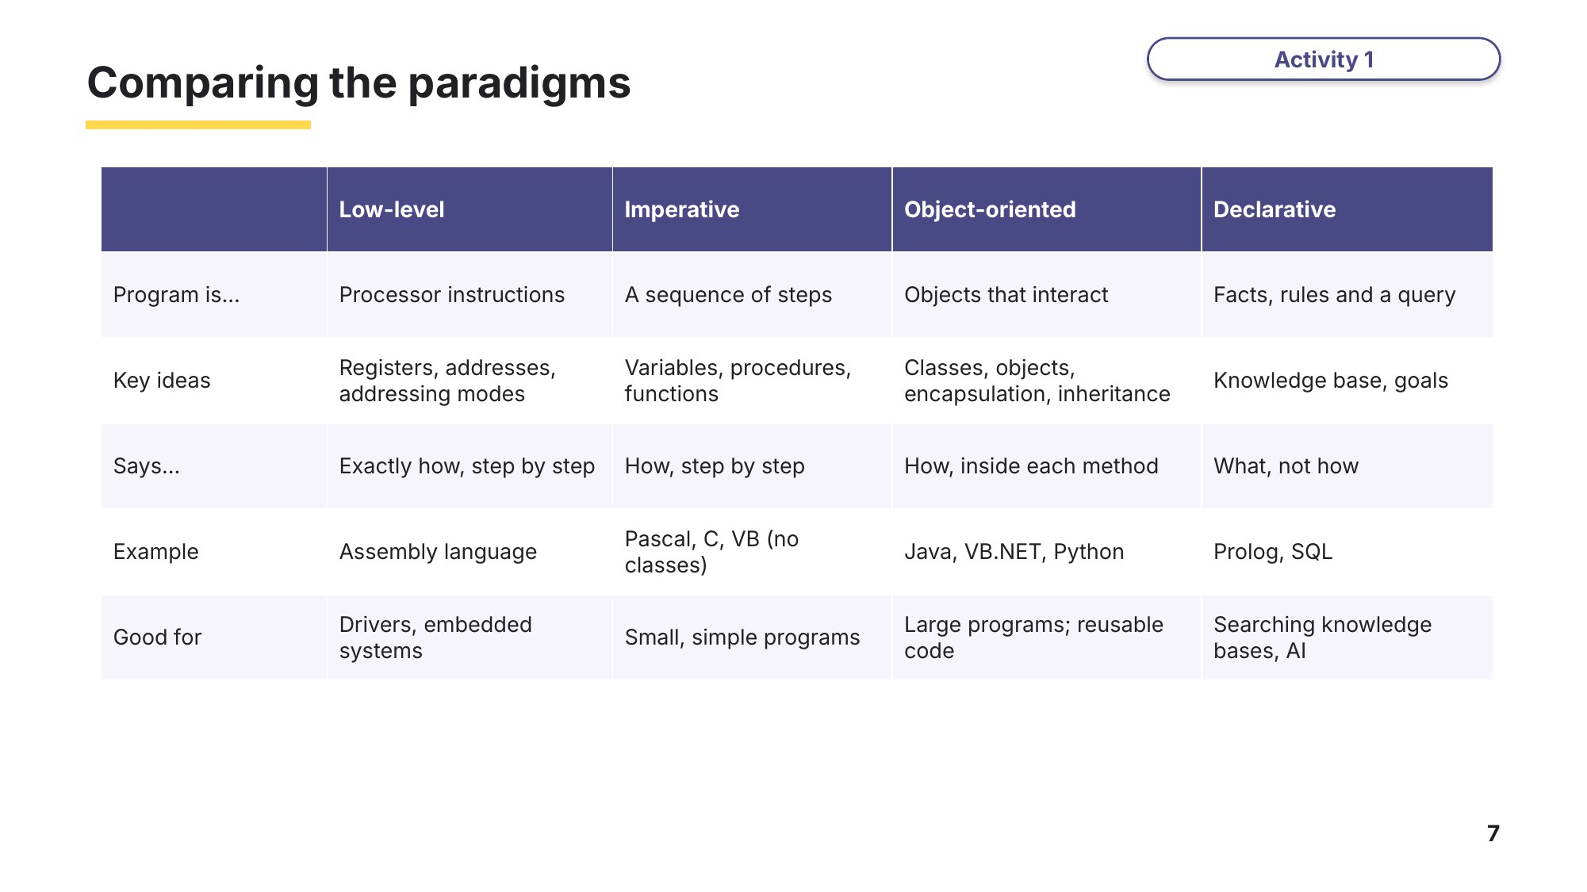
Slide 7 - Comparing the paradigms

Task 2 Paradigms and OOP key words [11 marks]
(a) Write the letter of the correct description next to each programming paradigm. One description is not used. [4]
Based on 9618/31 October/November 2021 Q2 (matching question).
Paradigm | Letter |  | Description
Low-level |  | A | Programs that specify the desired result rather than how to get to it
Imperative |  | B | Programs based on events such as user actions or sensor outputs
Object oriented |  | C | Programs using the instruction set of a processor
Declarative |  | D | Programs using the concepts of class, inheritance, encapsulation and polymorphism
 |  | E | Programs with an explicit sequence of commands that update the program state, with or without procedure calls

Learn Classes and objects
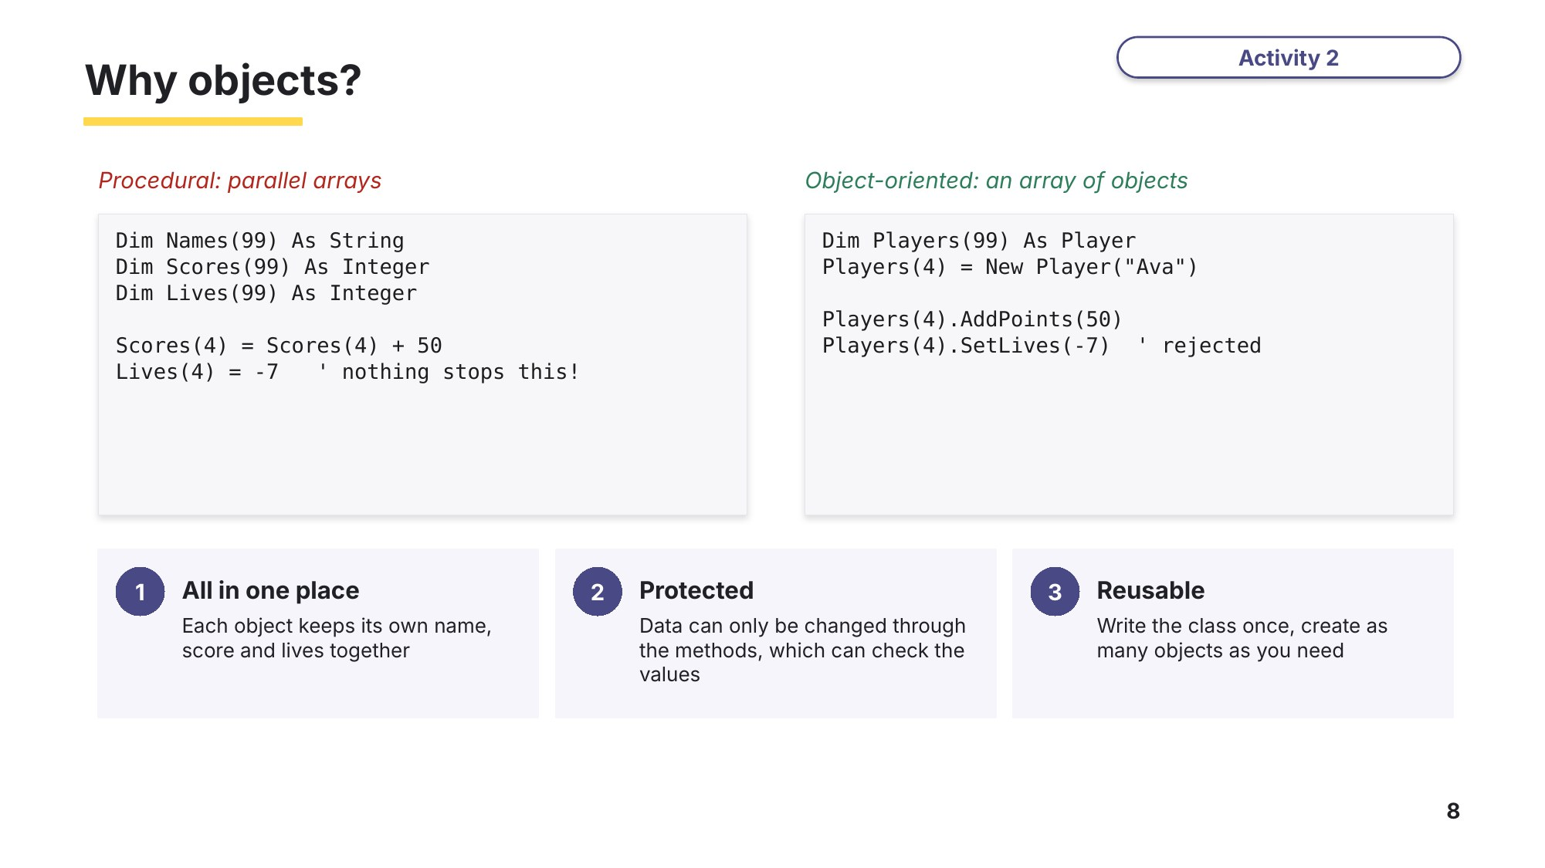
Slide 8 - Why objects?
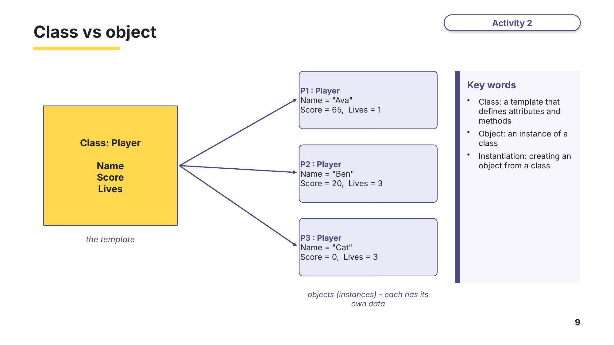
Slide 9 - Class vs object
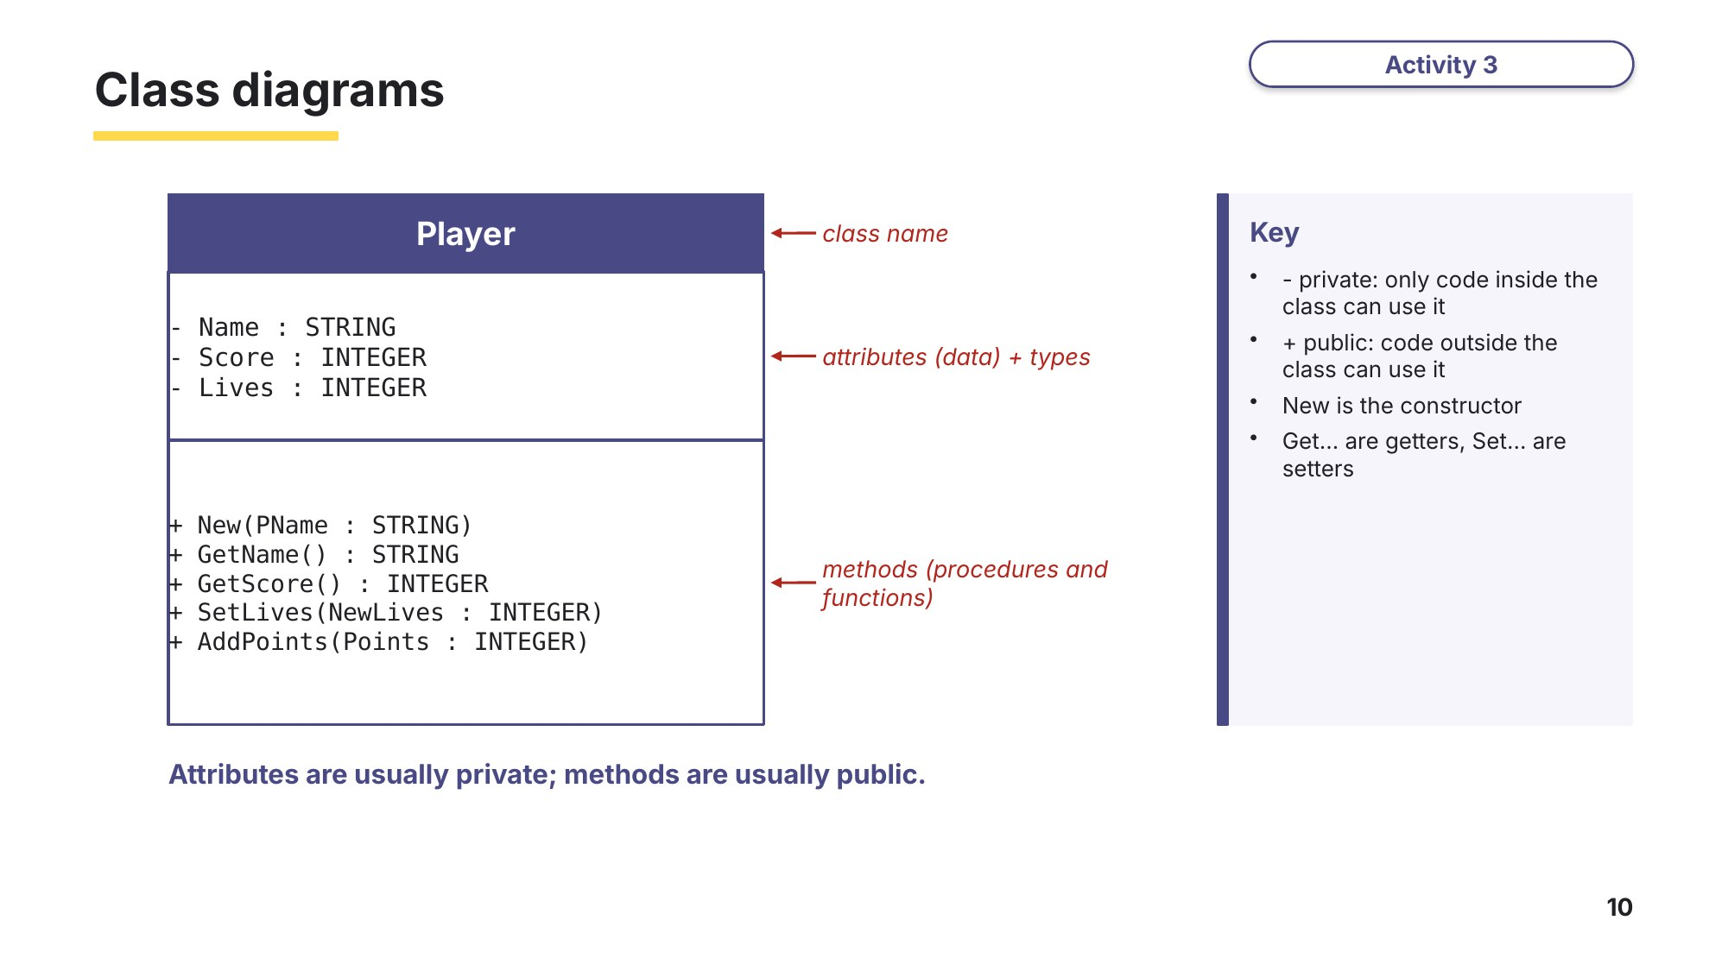
Slide 10 - Class diagrams
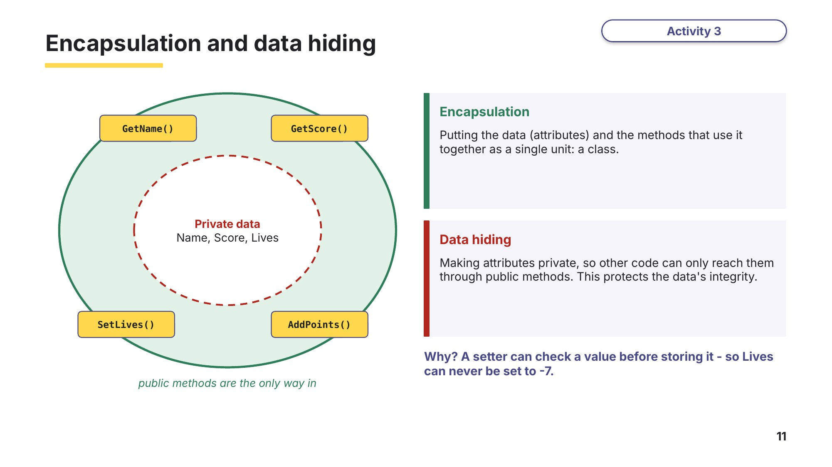
Slide 11 - Encapsulation and data hiding

(b) Write the letter of the correct description next to each term. One description is not used. [7]
Term | Letter |  | Description
Class |  | A | An instance of a class, with its own values for the attributes
Object |  | B | A method that returns the value of a private attribute
Attribute |  | C | A template that defines the attributes and methods of a type of object
Method |  | D | A data item stored in a class
Encapsulation |  | E | A method used to initialise a new object
Constructor |  | F | Putting data and the methods that use it together in one unit
Getter |  | G | A procedure or function defined as part of a class
 |  | H | A program that translates a class into machine code

Learn Writing a class in VB.NET
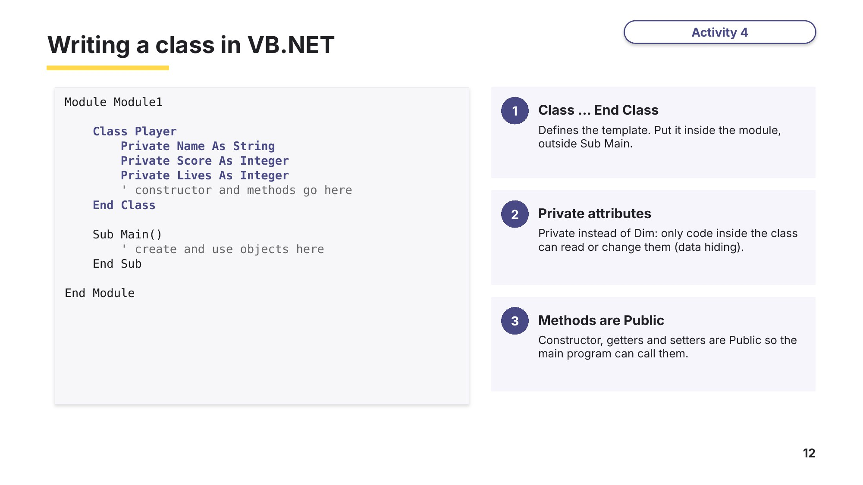
Slide 12 - Writing a class
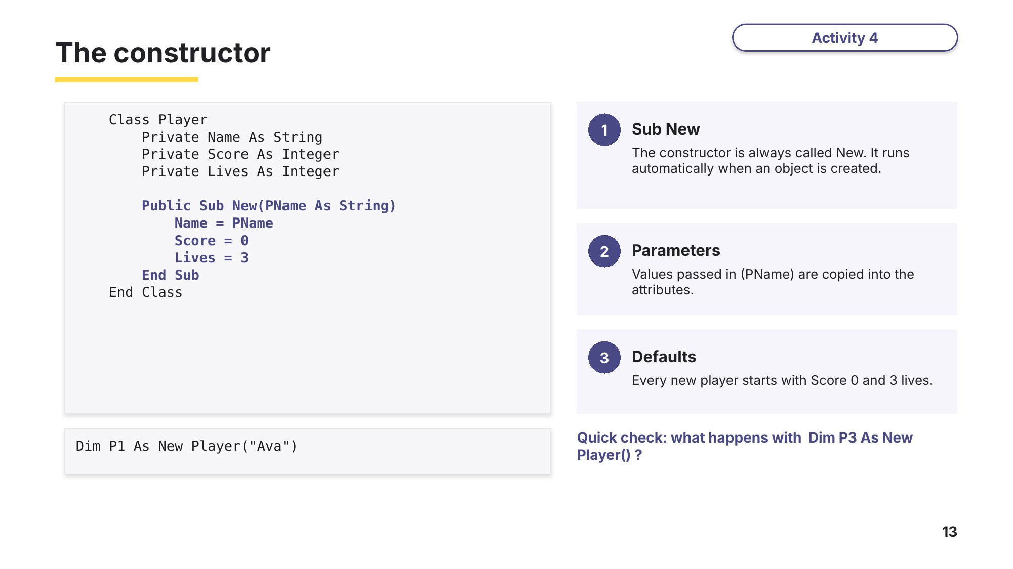
Slide 13 - The constructor
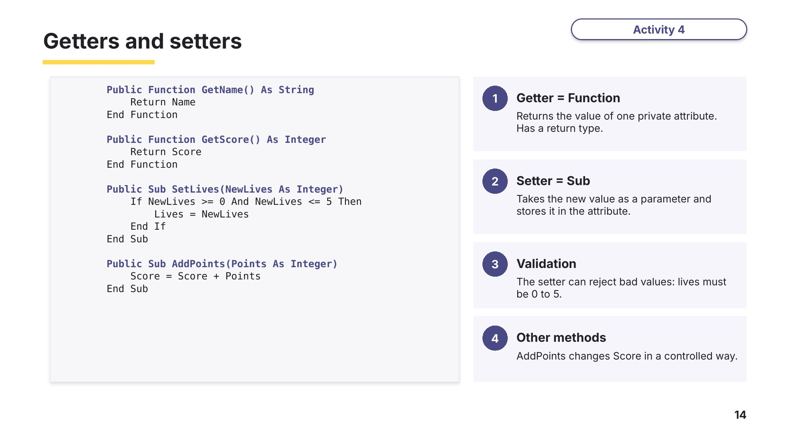
Slide 14 - Getters and setters
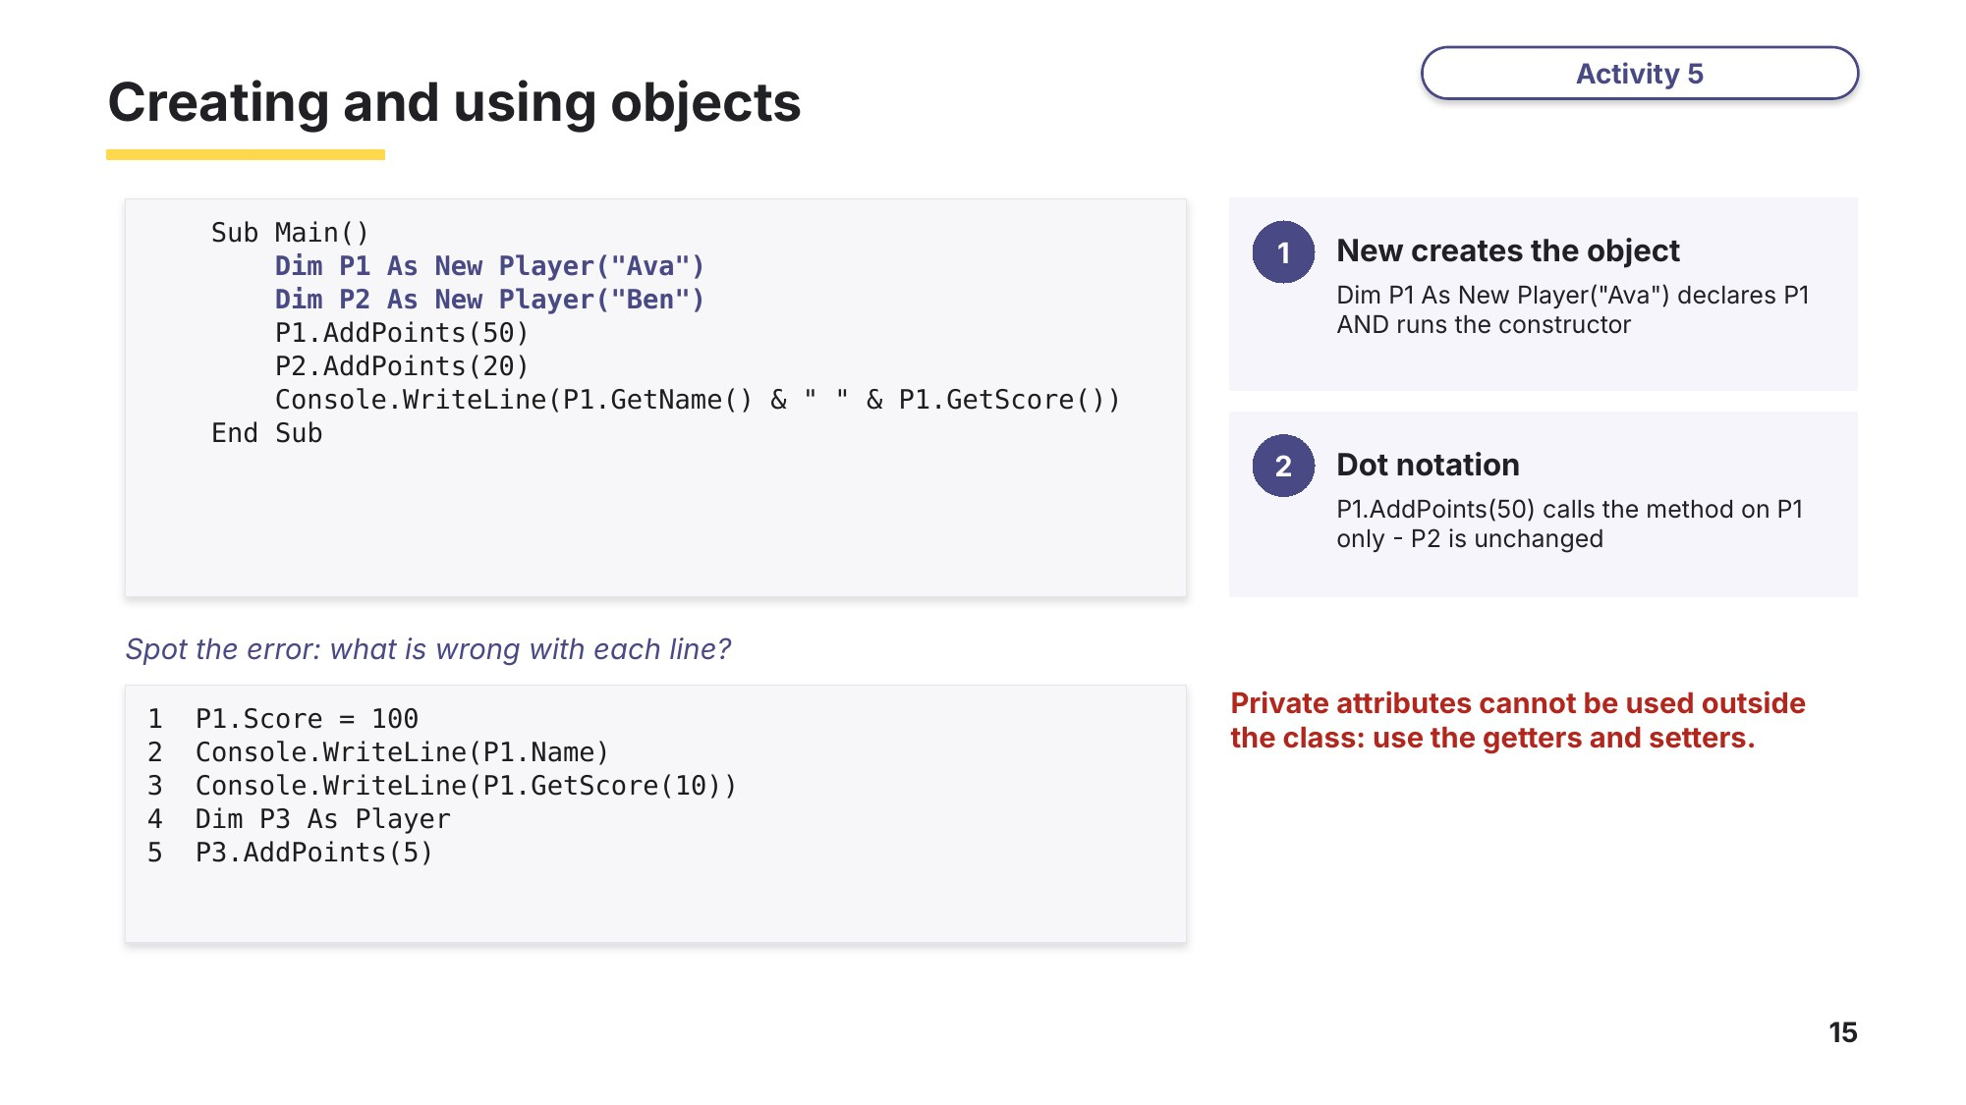
Slide 15 - Creating and using objects
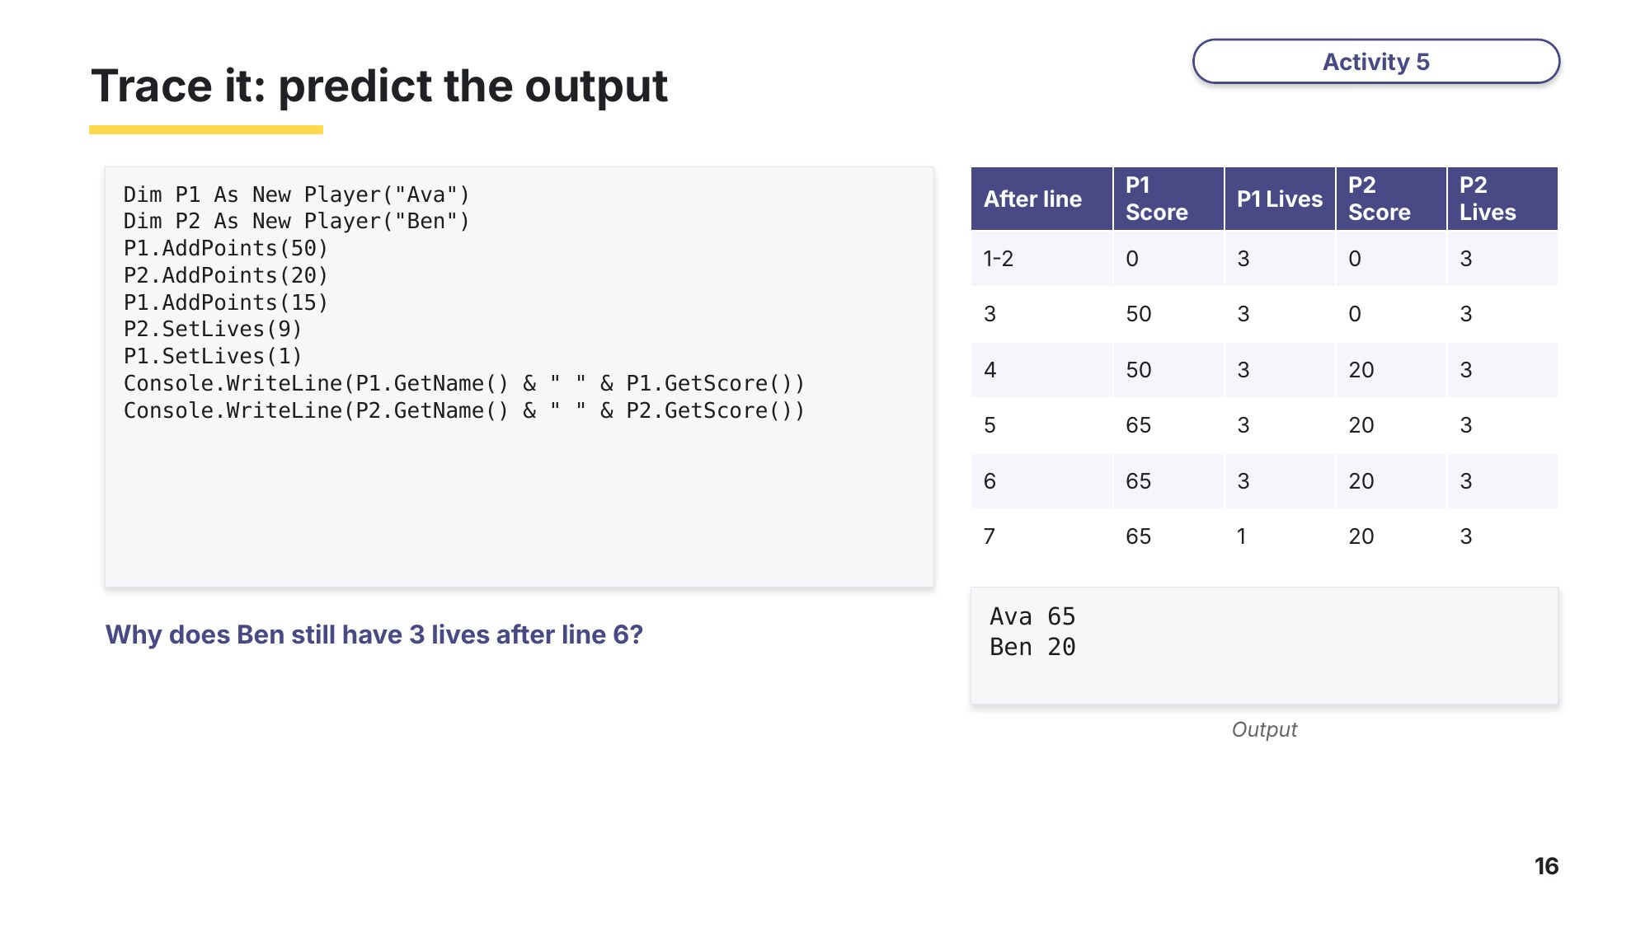
Slide 16 - Tracing objects

Task 3 Read and trace a class [11 marks]
A library program uses this class.
Class Book
Private Title As String
Private Author As String
Private Copies As Integer
Public Sub New(T As String, A As String, C As Integer)
Title = T
Author = A
Copies = C
End Sub
Public Function GetTitle() As String
Return Title
End Function
Public Function GetCopies() As Integer
Return Copies
End Function
Public Function Borrow() As Boolean
If Copies > 0 Then
Copies = Copies - 1
Return True
Else
Return False
End If
End Function
Public Sub ReturnCopy()
Copies = Copies + 1
End Sub
End Class
(a) Identify the three attributes of the class Book. [1]

(b) Identify the constructor and state when it runs. [2]

(c) Identify one getter in the class. [1]

(d) Explain why the attributes are declared as Private. [1]

(e) This main program uses the class. Complete the trace table and write down the output. [6]
1 Dim B1 As New Book("Dune", "Herbert", 2)
2 Dim B2 As New Book("Emma", "Austen", 0)
3 Console.WriteLine(B1.Borrow())
4 Console.WriteLine(B1.Borrow())
5 Console.WriteLine(B1.Borrow())
6 Console.WriteLine(B2.Borrow())
7 B2.ReturnCopy()
8 Console.WriteLine(B2.GetTitle() & " " & B2.GetCopies())
9 Console.WriteLine(B1.GetTitle() & " " & B1.GetCopies())
Line | B1 Copies | B2 Copies | Output
1-2
3
4
5
6
7
8
9

Learn Cambridge pseudocode
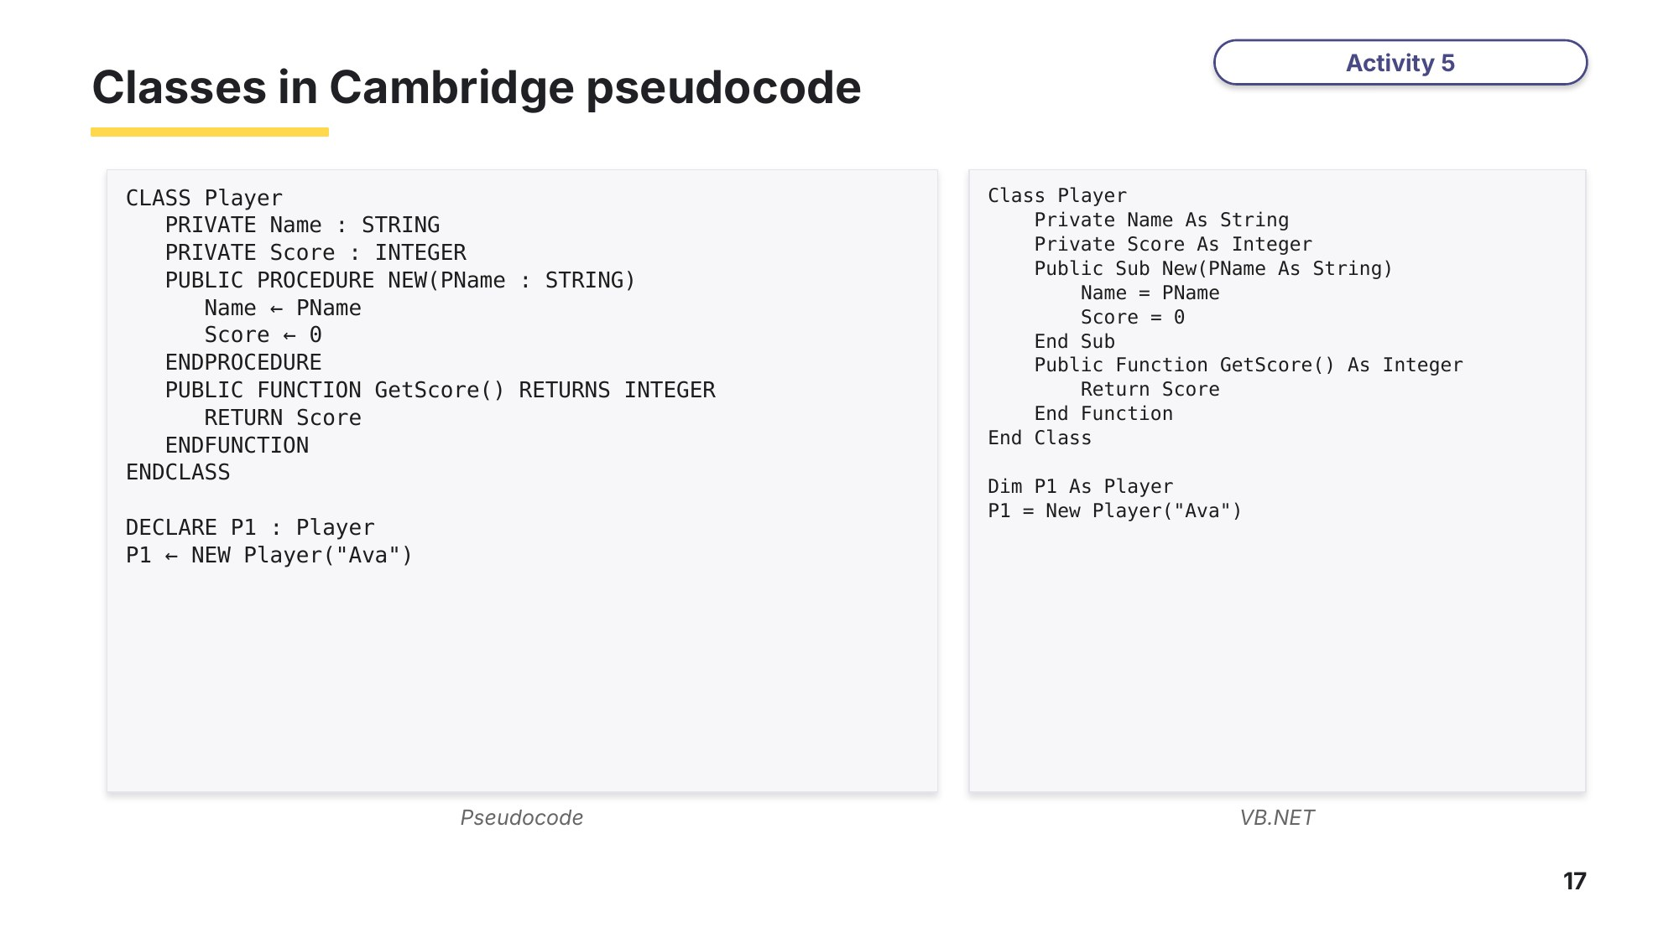
Slide 17 - Pseudocode vs VB.NET
Task 4 Complete the class [6 marks]
A vet's surgery uses the class Pet. Each pet has a name, a species and an age. A new pet has an age of 0. The age can only be set to a value from 0 to 30. Complete the VB.NET code by filling in the six gaps.
Class Pet
(1).............. Name As String
Private Species As String
Private Age As Integer
Public Sub (2)..............(PName As String, PSpecies As String)
Name = PName
Species = PSpecies
Age = 0
End Sub
Public (3).............. GetAge() As Integer
(4)..............
End Function
Public Sub SetAge(NewAge As Integer)
If NewAge >= 0 And NewAge <= 30 Then
(5)..............
End If
End Sub
End Class
Dim MyPet As (6).............. Pet("Rex", "dog")
Gap | Answer | Gap | Answer
(1) |  | (4)
(2) |  | (5)
(3) |  | (6)

Learn How examiners mark a class
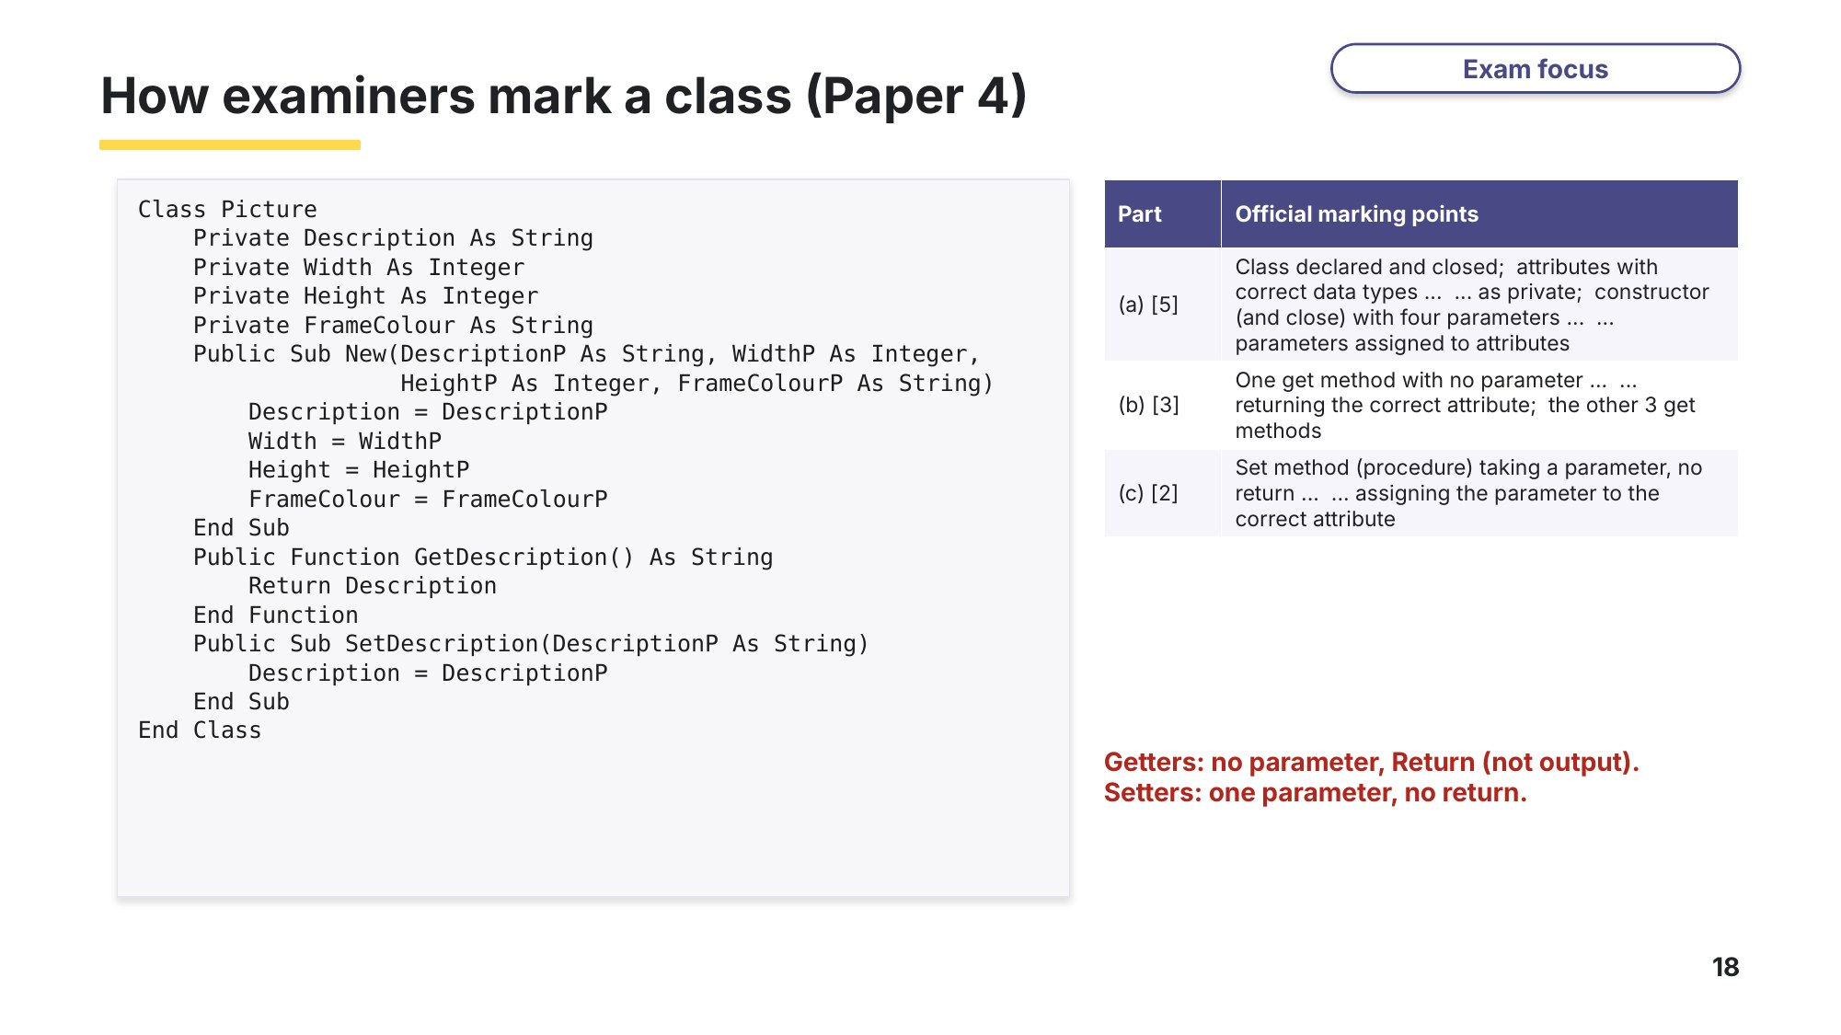
Slide 18 - How examiners mark a class (Paper 4)
Task 5 Write a class [15 marks]
A bank uses a class BankAccount. Start this in the lesson and finish it at home or at the computer.
BankAccount
AccountNumber : STRING stores the account number
Holder : STRING stores the name of the account holder
Balance : REAL stores the amount of money in the account
Constructor() takes the account number and holder name as parameters;
sets Balance to 0
GetBalance() returns the balance
Deposit() takes an amount as a parameter and adds it to the
balance, only if the amount is more than 0
Withdraw() takes an amount as a parameter; if the balance is at
least the amount, subtracts it and returns TRUE,
otherwise returns FALSE

(a) Write VB.NET code to declare the class BankAccount with its three private attributes and its constructor. [5]
Exam-style question (Paper 4 style).
(b) Write the methods GetBalance() and Deposit(). [4]
(c) Write a main program that creates an account with the account number "AC100" for "Mia Tan", deposits 100, withdraws 30 and outputs the balance. [3]
(d) Extension: write the method Withdraw(). [3]
Task 6 Real exam questions - homework or next lesson [23 marks]
Part A - Paper 3 (written answers)
(a) Describe what is meant by an imperative (procedural) programming language. [2]
9618/31 May/June 2021 Q9(a).

(b) Describe what is meant by a declarative programming language. [2]
9618/31 May/June 2021 Q9(b).

Objects and classes form the basic structure of Object-Oriented Programming (OOP).
(c) Outline the structure of a class. [3]
9618/32 October/November 2024 Q10(a).

(d) Give three differences between an object and a class. [3]
9618/32 October/November 2024 Q10(b).
1

2

3

(e) A veterinary surgery stores the details of pets in objects of the class Pet. State one reason why the attributes would be declared as PRIVATE. [1]
9618/31 October/November 2024 Q9(a).

Part B - Paper 4 (at the computer, VB.NET)
9618/41 May/June 2022 Q2(a), (b), (c) and (e).
A computer game has balloons that defend themselves. The class Balloon has these attributes and methods:
Balloon
Health : INTEGER the health of the balloon
Colour : STRING the colour of the balloon
DefenceItem : STRING the item the balloon uses to defend itself
Constructor() initialises the defence item and colour using the
parameters; initialises health to 100
ChangeHealth() takes the change as a parameter and adds this to
the health
GetDefenceItem() returns the defence item of the object

(f) Write program code to declare the class Balloon and its constructor. Do not declare the other methods. All attributes must be private. [5]
(g) The get method GetDefenceItem() returns the defence item. Write program code for GetDefenceItem(). [2]
(h) The method ChangeHealth() takes an integer number as a parameter and adds this to the health attribute of the object. Write program code for ChangeHealth(). [2]
(i) Write a main program that takes a defence item and a colour as input from the user, and creates a new balloon with the identifier Balloon1 using these values. [3]

Learn Exam technique - check your Task 6 Part A answers
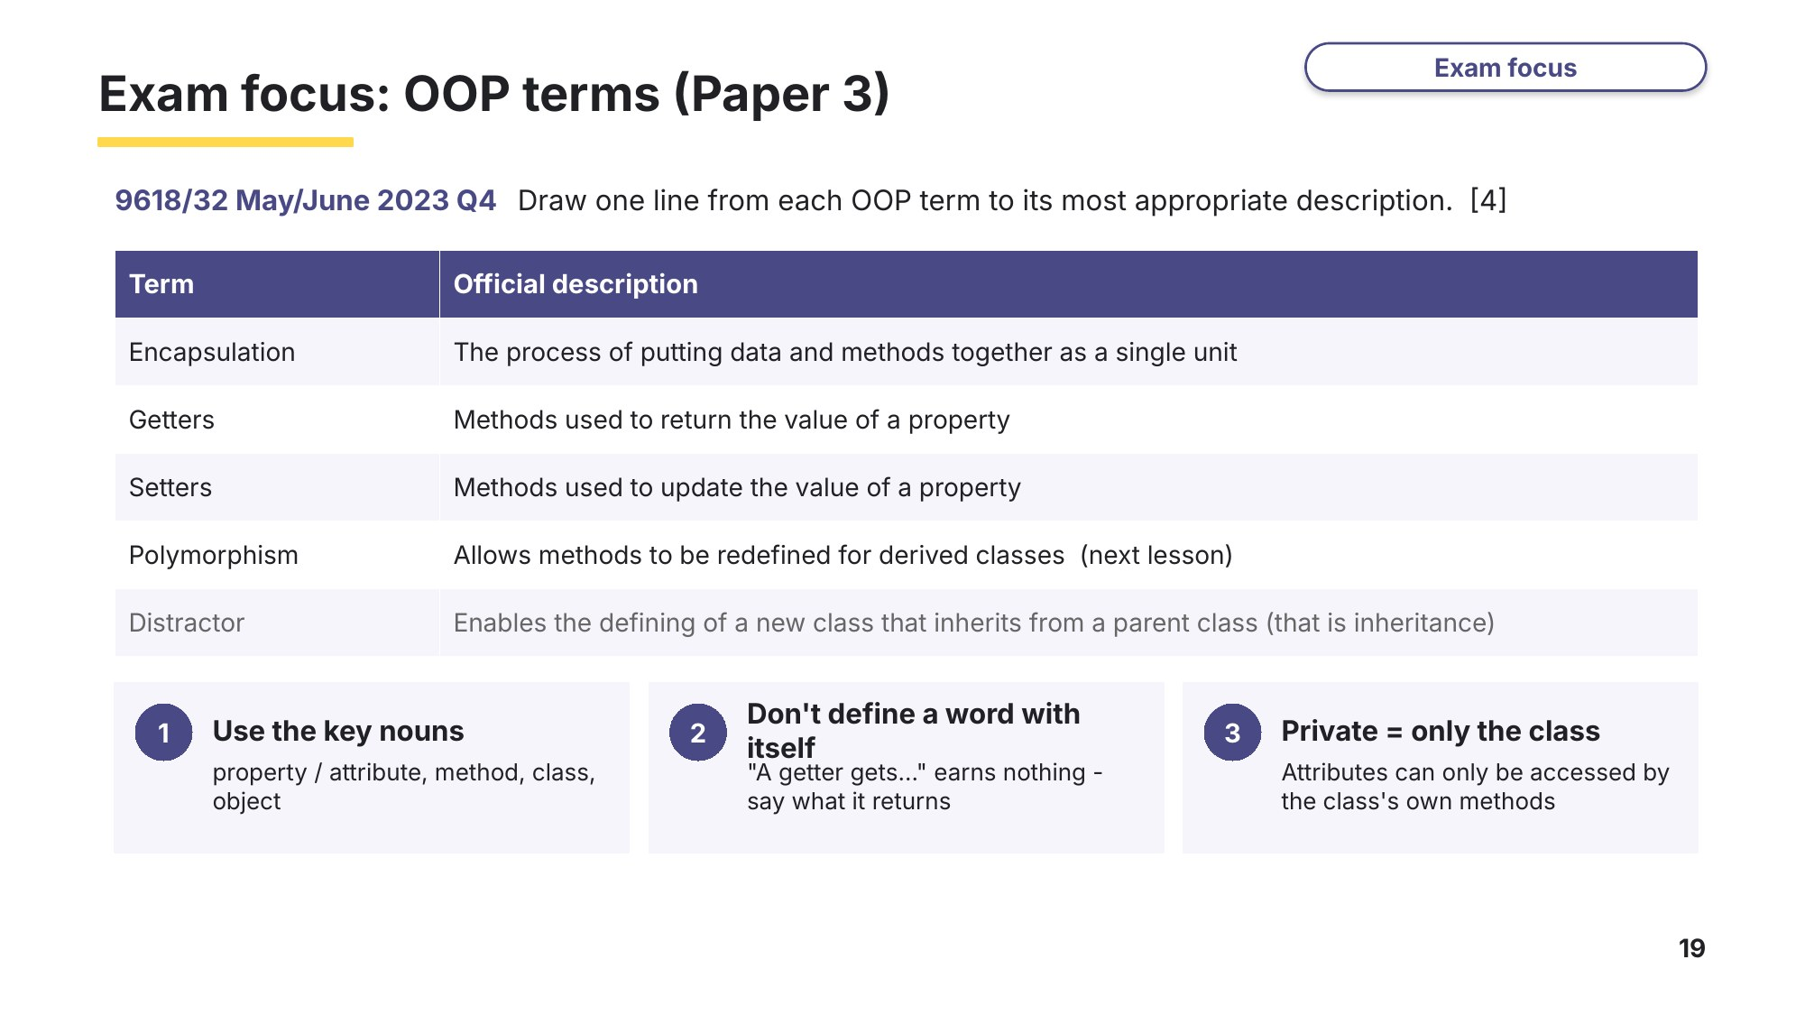
Slide 19 - Exam focus: OOP terms (Paper 3)

Learn Review
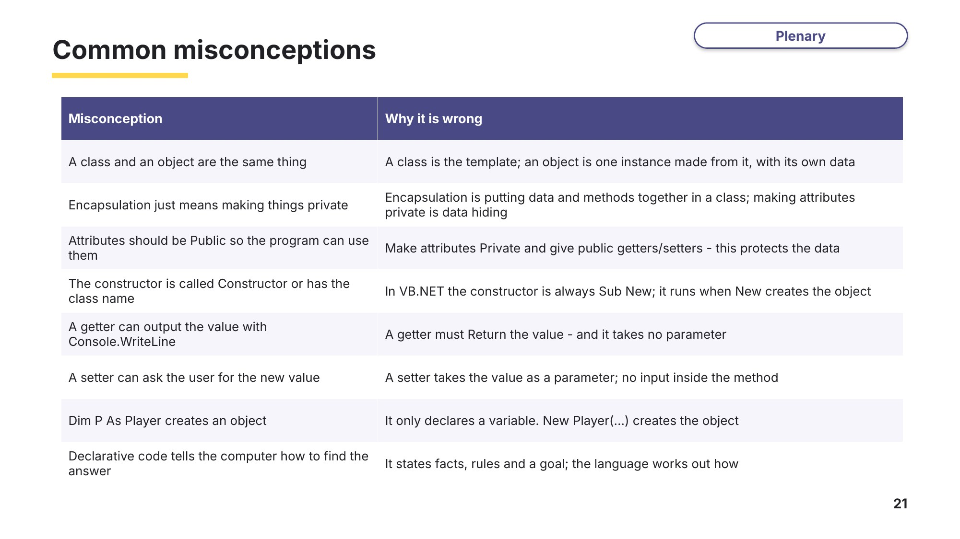
Slide 21 - Common misconceptions
Which of these did you believe before this lesson?
Exit question
(a) Explain the difference between a class and an object. [2]

(b) State one feature of encapsulation. [1]

(c) Write the VB.NET getter GetLives() for the Player class. [2]

